HANDS-ON LAB GUIDE
Multi-Agent Systems with an Orchestrator Agent
Upgrading a fixed, three-agent pipeline into a system where a small local AI model decides, at runtime, which specialist should handle the customer.
Prepared for: Vodafone Technical Training Session
Format: Instructor-led, hands-on

1. Objective
By the end of this lab, students will be able to:
- Explain the difference between a fixed multi-agent pipeline (Agent 1 → Agent 2 → Agent 3) and an orchestrator-based system where the route is decided dynamically.
- Build an Orchestrator Agent that uses a local AI model purely to classify a customer request into a category.
- Route that classification to the correct specialist agent (Billing, Roaming, or Technical) in Python.
- Apply prompt-engineering techniques — few-shot examples, deterministic generation, and strict output constraints — to make a small local model's classification reliable enough for a live demo.
- Correctly explain to students which part of the system is “the AI deciding” and which part is ordinary Python parsing that code.

2. Lab Scenario
You already built a Vodafone multi-agent demo (multi_agent.py) where three agents ran in a fixed order: Customer Analyst → Billing Specialist → Resolution Agent. That pipeline is useful, but it always runs the same three agents regardless of what the customer actually asked.
In this lab you upgrade that idea into multi_agent_system.py: a single Orchestrator Agent reads the customer's request, decides which specialist is relevant — Billing, Roaming, or Technical — and routes the request to that one specialist only. The other two specialists never run.
This is a much closer approximation of how production support systems and real multi-agent frameworks work: a lightweight routing step, followed by one specialist doing the actual work.
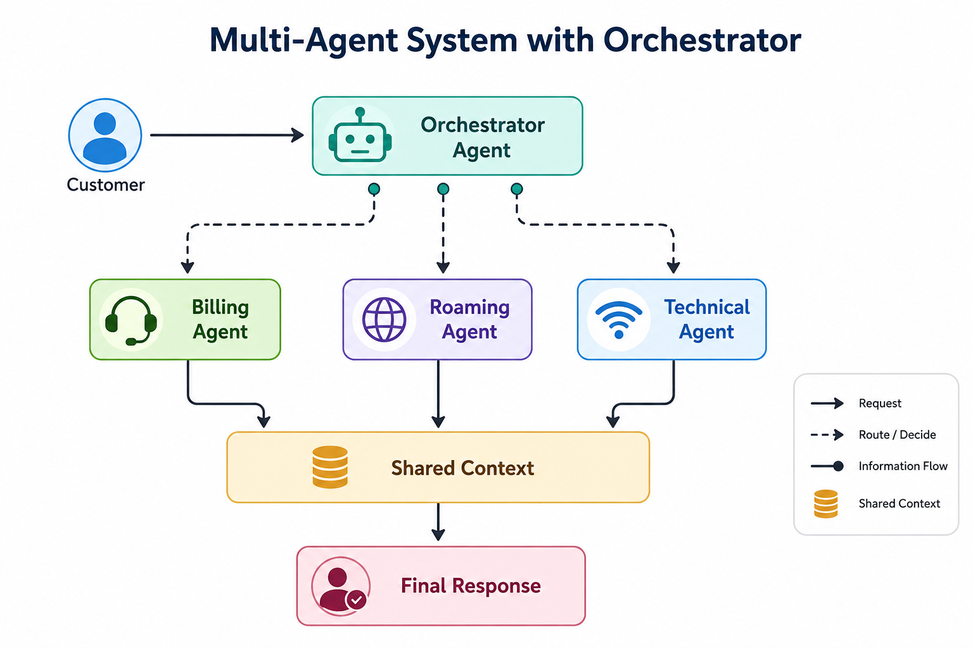
Figure 1 — The Orchestrator Agent reads the customer request, chooses one specialist, and that specialist's answer becomes the final response.

3. Why a Plain Orchestrator Prompt Is Unreliable
If you simply ask a small local model “which specialist should handle this?” in an open-ended way, it will sometimes reply with a full sentence, invent a category that doesn't exist, or hedge between two categories. That is fine for a large hosted model, but Qwen2.5-0.5B is small enough that it needs firmer guardrails to behave predictably in front of a class. Five changes make the Orchestrator Agent far more reliable while still letting the AI make the routing decision:
- Give the Orchestrator clear examples (few-shot prompting) instead of just a description of each category.
- Tell it to return ONLY one category — no explanation, no punctuation.
- Use deterministic generation (do_sample=False) so the same request always routes the same way.
- Extract the decision robustly in Python, rather than trusting the raw string to match exactly.
- Don't let the specialist descriptions confuse the model — keep each category's “use for” list short and unambiguous.
With those five changes, a request like the one below routes correctly and consistently:
"My 5G internet is not working"
↓
Orchestrator AI
↓
TECHNICAL
↓
Technical Agent

4. Architecture: Fixed Pipeline vs. Orchestrator
The key difference from the earlier demo is where the routing decision is made:

4.1 Earlier demo — fixed pipeline
agent1 → agent2 → agent3

The route was predetermined — every customer request went through all three agents in the same order, regardless of what was actually asked.

4.2 This lab — orchestrator decides at runtime
Customer
↓
Orchestrator AI
↓
"TECHNICAL"
↓
Technical Agent

The Orchestrator decides the route at runtime, based on the content of the request. Only the chosen specialist runs.

5. Part 1 — Build the Orchestrator and Specialist Agents
Create a file named multi_agent_system.py with the following content. It defines the Orchestrator Agent, the three specialist agents (Billing, Roaming, Technical), and a small routing table that connects the Orchestrator's decision to the right specialist function:
import os
from transformers import pipeline

ai = pipeline(
"text-generation",
model="Qwen/Qwen2.5-0.5B-Instruct"
)

def orchestrator(customer_request):
print("\n🤖 ORCHESTRATOR AGENT")
print("--------------------------------------")
print("Analyzing request...")

prompt = f"""
Your ONLY job is to choose the best specialist.

SPECIALISTS:

BILLING
Use for:
- High bill
- Unexpected charges
- Payment problems
- Plan charges

ROAMING
Use for:
- Travel abroad
- International usage
- Roaming charges

TECHNICAL
Use for:
- 4G or 5G problems
- Mobile internet not working
- Network problems
- SIM problems
- Phone connectivity problems

Here are examples:

Customer: My bill is £95 instead of £40.
Answer: BILLING

Customer: I travelled to Dubai and received roaming charges.
Answer: ROAMING

Customer: My 5G internet is not working.
Answer: TECHNICAL

Customer: My mobile network keeps disconnecting.
Answer: TECHNICAL

Customer: I was charged extra for my data.
Answer: BILLING

Now classify this customer request:

Customer:
{customer_request}

Answer with ONLY ONE WORD:
BILLING
ROAMING
TECHNICAL
"""

messages = [
{
"role": "system",
"content": "You are a routing agent. Return only one category."
},
{
"role": "user",
"content": prompt
}
]

response = ai(
messages,
max_new_tokens=5,
do_sample=False
)

decision = response[0]["generated_text"][-1]["content"].strip().upper()

print(f" Orchestrator decision: {decision}")

# Clean up the AI output
if "TECHNICAL" in decision:
return "TECHNICAL"

if "ROAMING" in decision:
return "ROAMING"

if "BILLING" in decision:
return "BILLING"

# Fallback
return "BILLING"

def billing_agent(customer_request):
print("\n📋 BILLING AGENT")
messages = [
{
"role": "system",
"content": "You are a Vodafone billing specialist. Explain the likely billing "
"cause clearly and briefly, in plain language."
},
{"role": "user", "content": customer_request}
]
response = ai(messages, max_new_tokens=100, do_sample=True, temperature=0.7)
return response[0]["generated_text"][-1]["content"]

def roaming_agent(customer_request):
print("\n🌍 ROAMING AGENT")
messages = [
{
"role": "system",
"content": "You are a Vodafone roaming specialist. Explain the likely roaming "
"cause clearly and briefly, in plain language."
},
{"role": "user", "content": customer_request}
]
response = ai(messages, max_new_tokens=100, do_sample=True, temperature=0.7)
return response[0]["generated_text"][-1]["content"]

def technical_agent(customer_request):
print("\n📱 TECHNICAL AGENT")
messages = [
{
"role": "system",
"content": "You are a Vodafone technical support specialist. Give a short, "
"practical troubleshooting suggestion."
},
{"role": "user", "content": customer_request}
]
response = ai(messages, max_new_tokens=100, do_sample=True, temperature=0.7)
return response[0]["generated_text"][-1]["content"]

AGENTS = {
"BILLING": billing_agent,
"ROAMING": roaming_agent,
"TECHNICAL": technical_agent
}

print("\n======================================")
print(" VODAFONE MULTI-AGENT SYSTEM")
print("======================================")

customer_request = input("\nEnter customer request:\nCustomer: ")

decision = orchestrator(customer_request)
print(f"Decision: {decision} AGENT")

print("\n➡️ Routing request...")
selected_agent = AGENTS[decision]
final_response = selected_agent(customer_request)

print("\n======================================")
print(" FINAL RESPONSE")
print("======================================")
print(final_response)

print("\n======================================")
print(" COMPLETE")
print("======================================\n")

Run it from the terminal:
python multi_agent_system.py

Instructor note
The first run will print a Hugging Face warning about unauthenticated requests and a weight-loading progress bar — this is normal and does not affect the demo. It only appears while the model is loading.

6. The Key Teaching Point: What Is the AI Actually Deciding?
Don't present the if "TECHNICAL" in decision lines as the AI making the decision. The AI already made the decision — those lines are simply parsing and validating the AI's output so the demo doesn't break on an unexpected reply.
The actual decision happens here:
Customer request
↓
Qwen
↓
"TECHNICAL"

The Python code that follows then simply says, in effect: “Okay, the AI selected TECHNICAL. I'll invoke the Technical Agent.” That distinction — AI decides, Python routes — is what makes this a clean demonstration of an Orchestrator Agent rather than a scripted if/else chain dressed up as AI.
Instructor note
Because you're using the small Qwen 0.5B model running locally, the few-shot examples in the prompt are what make the live classroom demo considerably more reliable. Without them, the same request can occasionally be classified inconsistently.

7. Part 2 — Test the Orchestrator
Run the script three times and enter each of the customer requests below. Compare your output against the expected result shown underneath each one.

7.1 Test 1 — Billing
Customer: My Vodafone bill is £95 but I normally pay £40.
🤖 ORCHESTRATOR AGENT
--------------------------------------
Analyzing request...
Orchestrator decision: BILLING

➡️ Routing request...

📋 BILLING AGENT

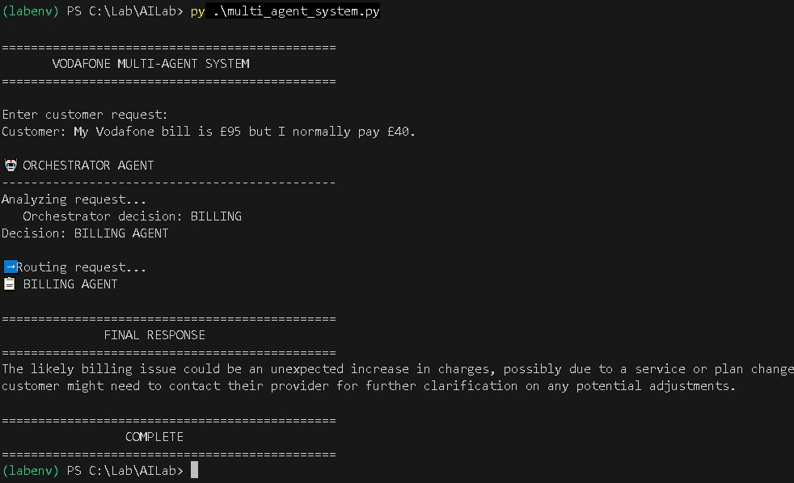
Figure 2 — Test 1 in the terminal: the Orchestrator correctly classifies the request as BILLING and routes to the Billing Agent.

7.2 Test 2 — Roaming
Customer: I travelled to Dubai and now I have a huge roaming charge.
🤖 ORCHESTRATOR AGENT
--------------------------------------
Analyzing request...
Orchestrator decision: ROAMING

➡️ Routing request...

🌍 ROAMING AGENT

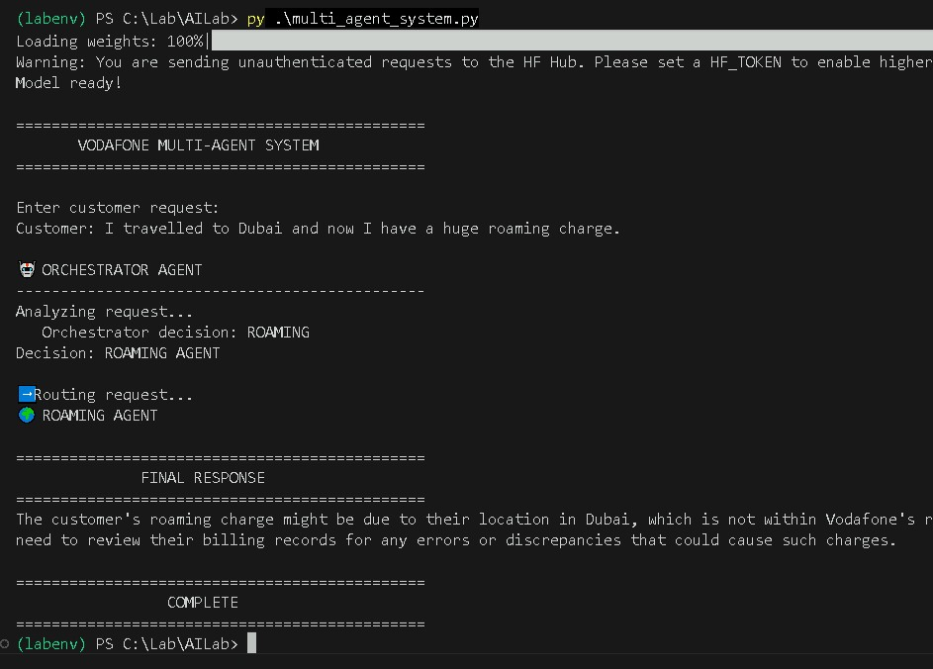
Figure 3 — Test 2 in the terminal. Note the Hugging Face loading warning above the banner — this is expected on first run.

7.3 Test 3 — Technical (the one that was failing)
Customer: My 5G internet is not working on my phone.
🤖 ORCHESTRATOR AGENT
--------------------------------------
Analyzing request...
Orchestrator decision: TECHNICAL

➡️ Routing request...

📱 TECHNICAL AGENT

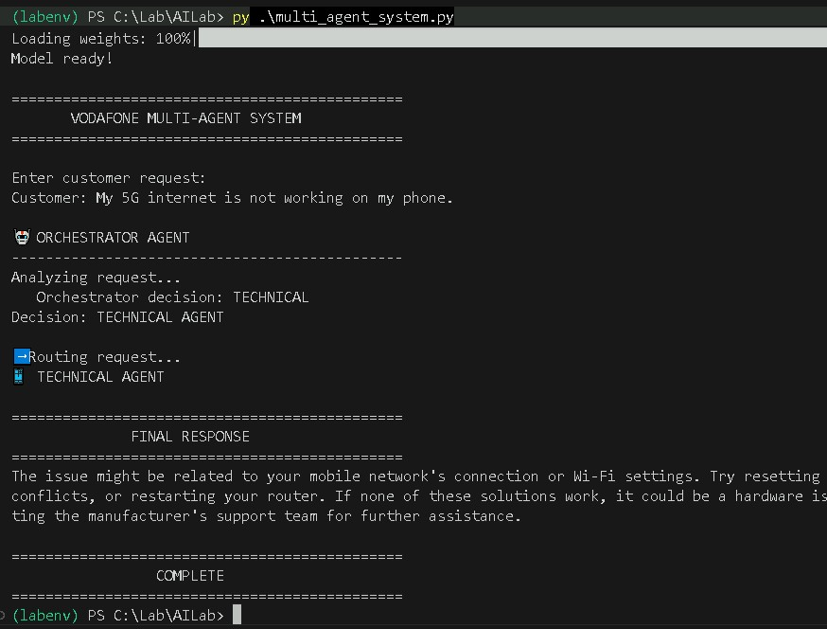
Figure 4 — Test 3 in the terminal. Before the few-shot examples and do_sample=False were added, this request was the one most likely to be misclassified.
Before you added the five improvements in Section 3, this third request was the one most likely to be misrouted — a small model can easily confuse “internet not working” with a billing or plan issue without a clear TECHNICAL example to anchor it. That's exactly why it's included here as the test case.

8. What to Explain to Students
Use these talking points alongside the architecture diagram in Section 2 as you run the live demo:
- The Orchestrator Agent is not a different model — it's the same local Qwen model, called with a very constrained prompt whose only job is classification.
- max_new_tokens=5 and do_sample=False are deliberate: they keep the Orchestrator's output short and repeatable, which matters far more for a routing step than for a conversational answer.
- The few-shot examples in the prompt (BILLING / ROAMING / TECHNICAL with sample customer lines) are what raise reliability on a small local model — remove them and reclassification becomes noticeably less consistent.
- The if "TECHNICAL" in decision checks are Python validating and cleaning the AI's output, not the AI itself — the decision was already made by the model.
- Only the chosen specialist agent runs. Unlike the earlier fixed pipeline, the other two specialists are never invoked for a given request.
- A dictionary (AGENTS = {"BILLING": billing_agent, ...}) is what turns the Orchestrator's text decision into an actual function call — this pattern generalises to any number of specialists.

9. Summary
Students leave this lab having converted a fixed, three-step agent pipeline into a routed multi-agent system, where a small local model makes a live classification decision and Python dispatches the request to the correct specialist. This orchestrator pattern — classify, then route, then let one specialist answer — is the same shape used by production customer-support systems and larger multi-agent frameworks, just without the added orchestration library.
Suggested next step
Once comfortable with a single Orchestrator and three specialists, students can discuss what changes at scale: how routing prompts need to evolve with more categories, and when a rules-based classifier (instead of an LLM) might be the more reliable choice for high-volume, low-ambiguity routing.

